**Experiment No 12**

**Name:Ajinkya Patil**

**Div:D15B**

**Roll No.:46**

**Batch C**

**AIM:To create a Lambda function which will log “An Image has been added” once you add an object to a specific bucket in S3**

**steps :**

**Open up the S3 Console and create a new bucket**

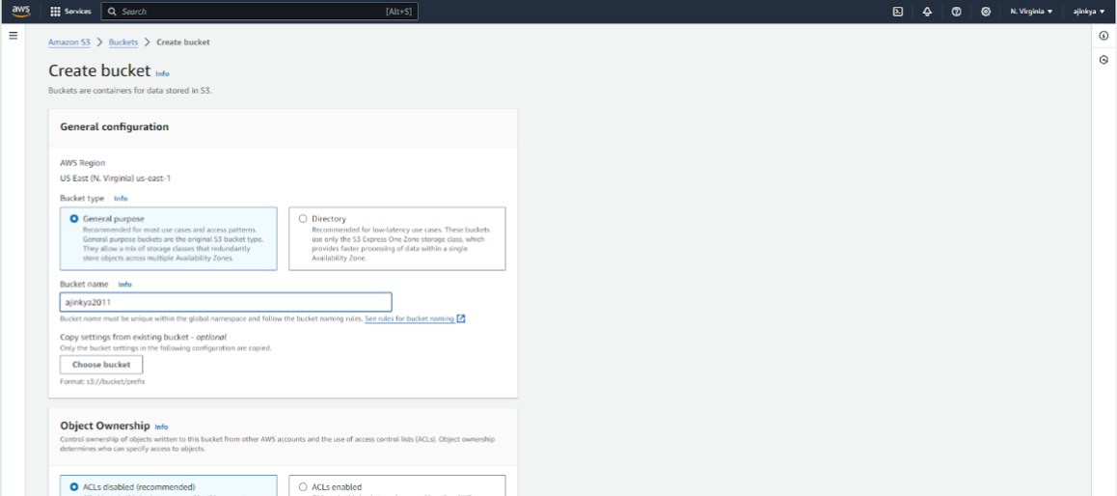

**Create Choose Lambda function as destination and choose your lambda function and save**

**the changes.**

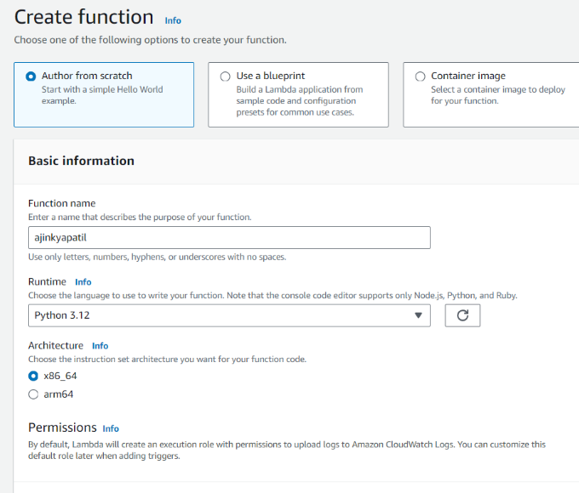

**Updated the function**

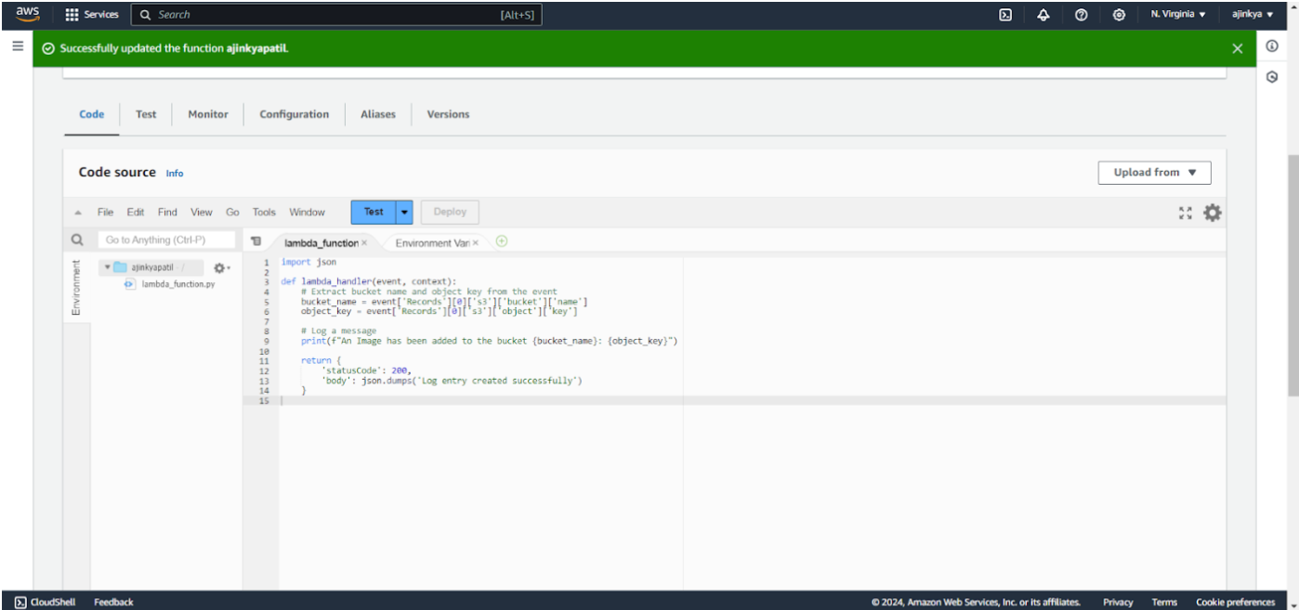

**Add trigger**

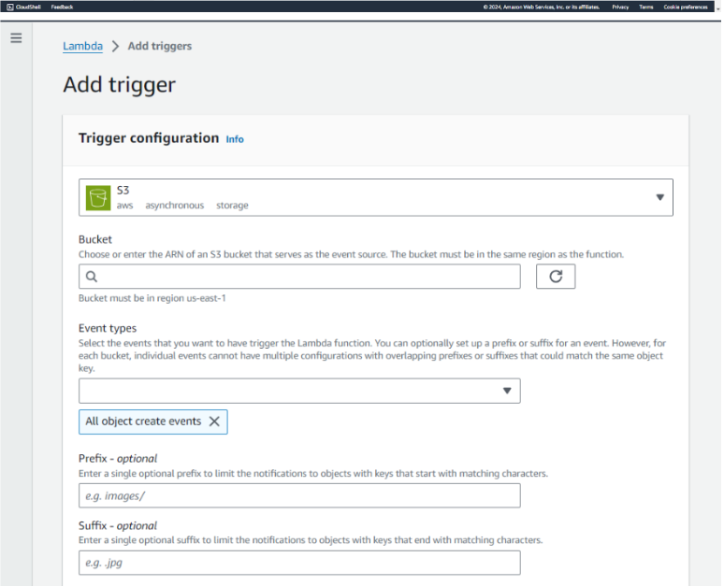

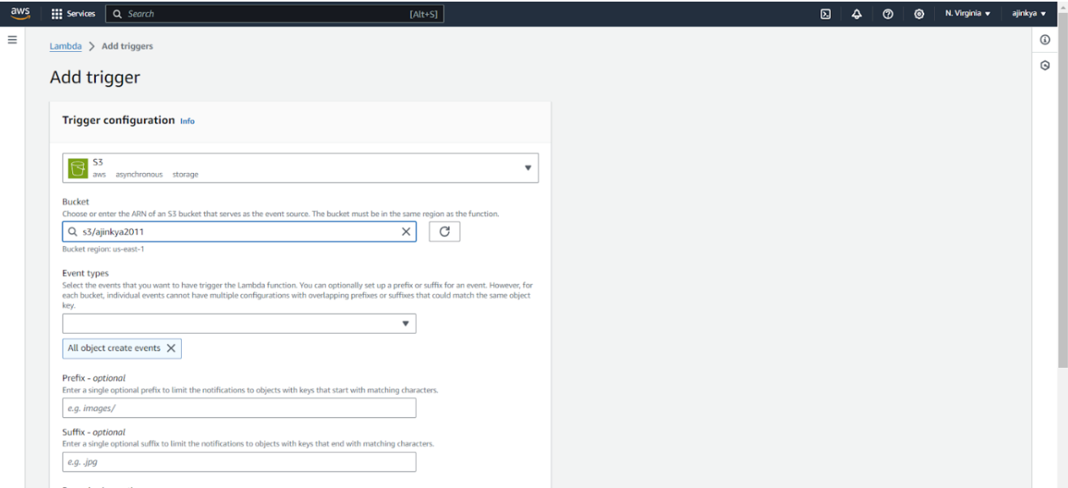

**Uploading files and folders**

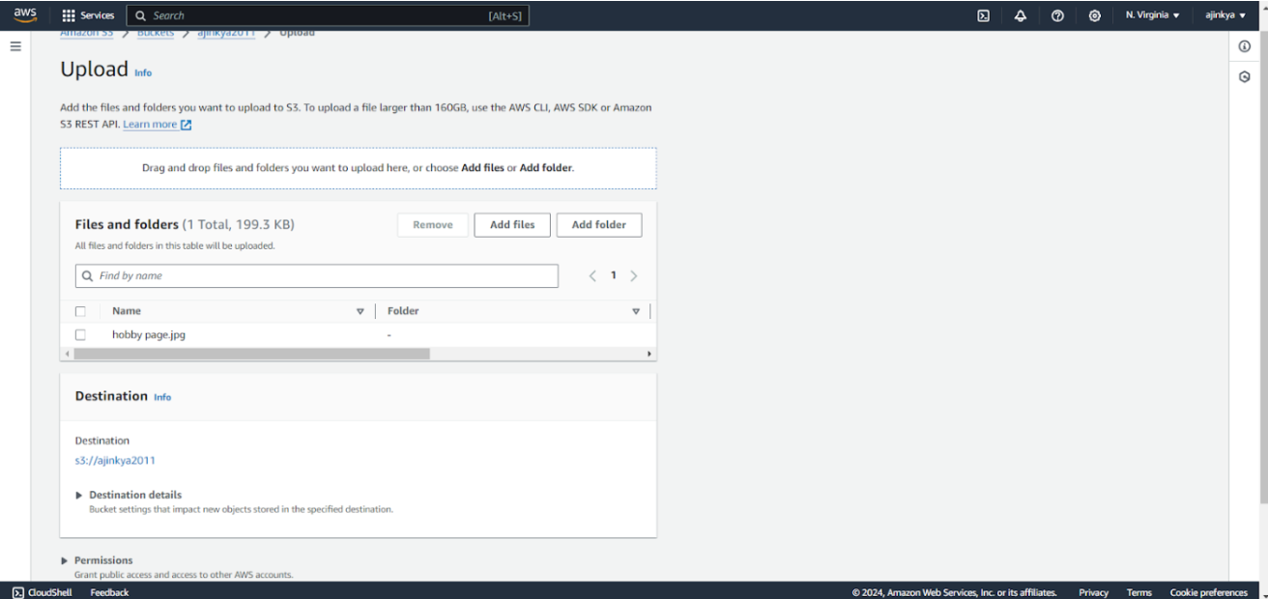

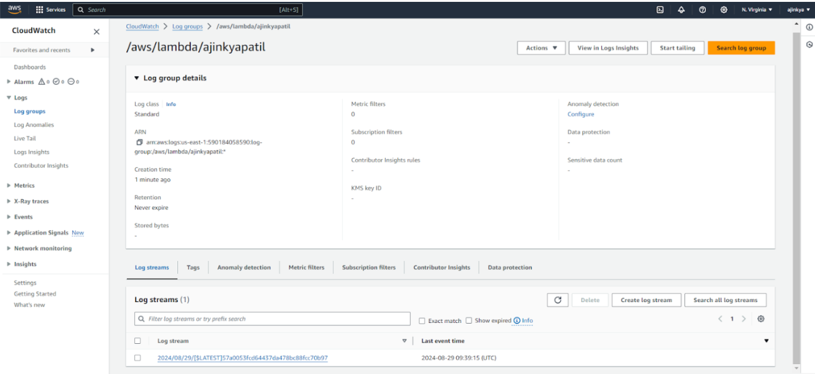

**Click on this log Stream that was created to view what was logged by**

**your function.**

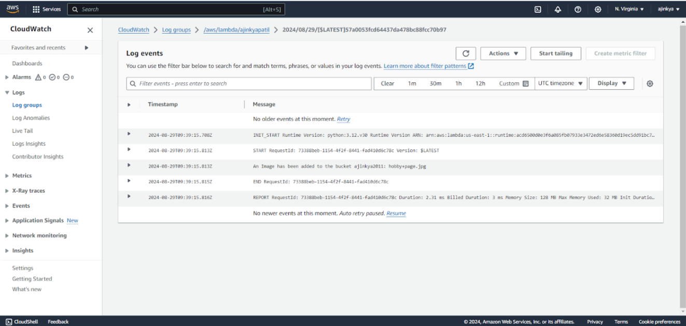

**Conclusion:**

Thus, we have successfully created an AWS Lambda function that logs “An Image has been added” whenever an object is added to a specific S3 bucket. This demonstrates the power of event-driven architecture, enabling automated actions in response to changes in cloud storage without the need for manual intervention.